**Effect of Volatility Risk Premium (VRP) on Option Mispricing**

**Main paper**: <https://papers.ssrn.com/sol3/papers.cfm?abstract_id=889947>

**Methodology**: portfolio sorting

**Description**: Option prices are functions of observables (such as underlying price, expiration, moneyness etc.) and unobservables (underlying volatility). Since all option pricing models require at least an estimate of the parameters that characterize the probability distribution of future volatility, volatility mis-measurement is the most obvious source of options mispricing. We sort stocks based on the difference between RV and IV. The motivation for this sorting cri- terion is based on two empirical regularities. One, volatility is highly persistent (as reported earlier, the autocorrelation coefficient for individual realized stock volatility in our sample is close to 0.95). Second, IV from an option is the markets estimate of future volatility of the underlying asset.8 Therefore, while there need not exist close correspondence be- tween RV and IV, large deviations between these two volatility estimates are indicative of volatility mispricing of options. For instance, stocks for which IV is much lower than RV are suspected to be underpriced. We explore these conjectures in this section by forming option portfolios.

**Very large deviations between these two volatility estimates are a signal of volatility mispricing.**

**To do**:

**1)** sort stocks into deciles based on the log difference between RV and IV. Decile ten con- sists of stocks with the highest (positive) difference while decile one consists of stocks with the lowest (negative) difference between these two volatility measures.

Sort stocks into deciles based on the log difference between their one year historical RV and their at-the-money IV. RV is calculated using the standard deviation of realized daily stock returns over the most recent twelve months. For each stock, we obtain the IV estimate from one month to maturity, at-the-money (ATM) options. In order to partially limit measurement errors we compute the stock’s IV by taking the average of the ATM call and put implied-volatilities. This also ensures that we construct a homogenous sample with respect to the options’ contract characteristics across stocks, and that we consider the most liquid options contracts for each stock. We form portfolios of options for each of these deciles.

**2)** Calculate greeks for the options (or get them via Option Metrics)

**3)** construct time series of call, put, straddle, and delta-hedged call/put returns for each stock in the sample. Do not include stale quotes in our analysis ( eliminate from the sample all the observations for which both the bid and the ask are equal to the previous day quotes).

Skip a day after the day that we obtain the signal (difference between RV and IV) for sorting stocks.

The returns are constructed using, as a reference beginning price, the average of the closing bid and ask quotes and, as the closing price, the terminal payoff of the option depending on the stock price at expiration and the strike price of the option

After expiration the next month, a new option with the same characteristics is selected and a new monthly return is calculated. Prices and returns for the underlying stock are taken from the CRSP database.

Equally-weighted monthly returns on calls, puts, and underlying stocks of each portfolio are computed and the procedure is then repeated for every month in the sample.

The straddle portfolios are formed as a combination of one call and one put. For delta-hedged portfolios, we use the delta (based on the current IV) provided to us by Option Metrics

**4)** reports the returns on options portfolios, like this:

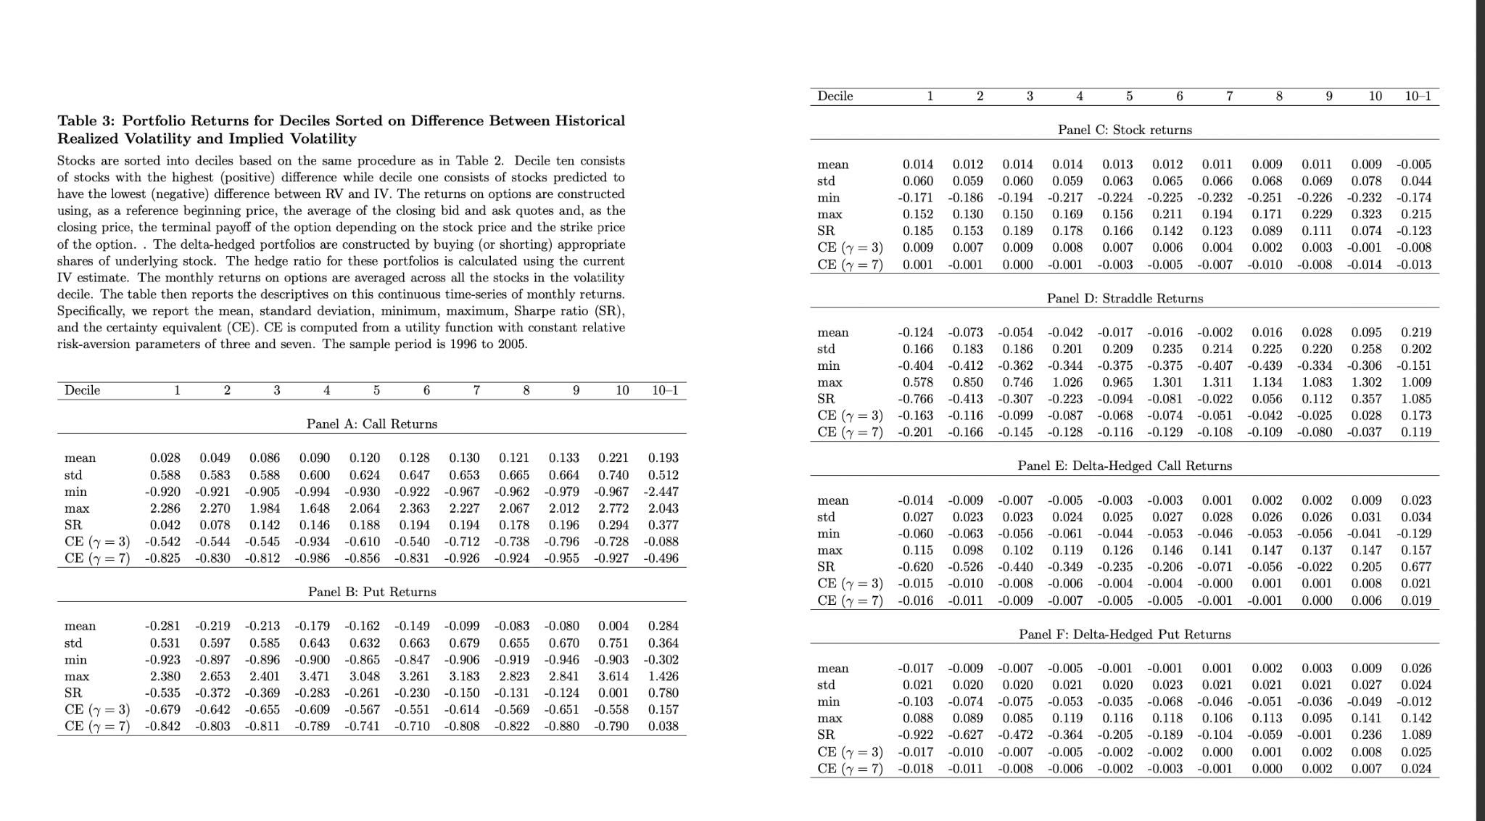

**FROM HERE, FOCUS THE NEXT SECTIONS ONLY ON THE STRATEGY WHOSE RETURNS ARE MOST CLEARLY LINKED TO THE SOURCE OF PROFITABILITY**

**5)** Create portfolios sorted based only on the level of implied volatility, and compare results with previous ones.

**6)** We proceed by examining whether the profitability of the straddles portfolio is related to aggregate risk. We regress the long-short straddles portfolio return on various specifications of a linear pricing model composed by the Fama and French (1993) three factors, the Carhart (1997) momentum factor, and the Coval and Shumway (2001) aggregate volatility factor represented by the excess return on a zero-beta S&P 500 index ATM straddle. Since all the factors are spread traded portfolios, the intercept from these regressions can be interpreted as an alpha. However, option payoffs are non-linearly related to payoffs of stocks. Therefore, a linear factor model is unlikely to characterize the cross-section of option returns. We use a linear model merely to illustrate that the option returns described in this paper are not related to aggregate sources of risk in an obvious way.

**7)** There is a large body of literature that documents that transaction costs in the options market are quite large and are in part responsible for some pricing anomalies, such as violations of the put-call parity relation.1Itisessentialtounderstandtowhatdegreethese frictions prevent an investor from exploiting the profits on portfolio strategies studied in this paper. Therefore, in this section we discuss the impact of transaction costs, measured by the bid-ask spread and margin requirements, on the feasibility of the long-short strategy.

We consider the costs associated with executing the trades at prices inside the bid-ask spread

Since transactions data is not available to us, we consider three effective spread measures equal to 50%, 75%, and 100% of the quoted spread. In other words, we buy (or sell) the option at prices inside the spread. This is done only at the initiation of the portfolio since we terminate the portfolio at the expiration of the option.

In addition, to address the concern that the results might be driven by options that are thinly traded, we repeat the analysis by splitting the sample into different liquidity groups. For each stock we compute the average quoted bid-ask spread and the daily average dollar volume in the previous month of all the option contracts traded on that stock. We then sort stocks based on these characteristics and calculate average returns and t-statistics for the long-short straddles portfolios for these groups of stocks

**Conclusion**: One should, thus, view our portfolios sorts as sorts on option prices with decile one (ten) representing over-(under-)priced options

One possibility is that volatility mispricing stems from the fact that economic agents do not use all the available information in forming expectations about future stock volatilities. In particular, they ignore the information contained in the cross-sectional distribution of implied volatilities and consider assets individually when forecasting volatility.

The information contained in historical realized volatility and implied volatility (based on readily available data) allows one to construct profitable trading strategies

**Advice:** use the 2021 dataset from Option Metrics, as it provides both historical volatility and implied volatility, and bid-ask spreads